Making a right turn on a pedal cycle
Right turns involve crossing both the traffic in your own direction and the traffic coming from the opposite direction, and sometimes traffic right turning from other arms of a junction. Quite a lot of thought has gone into how to make right turns safely. On Healthy Rides we occasionally make a 2-stage right turn.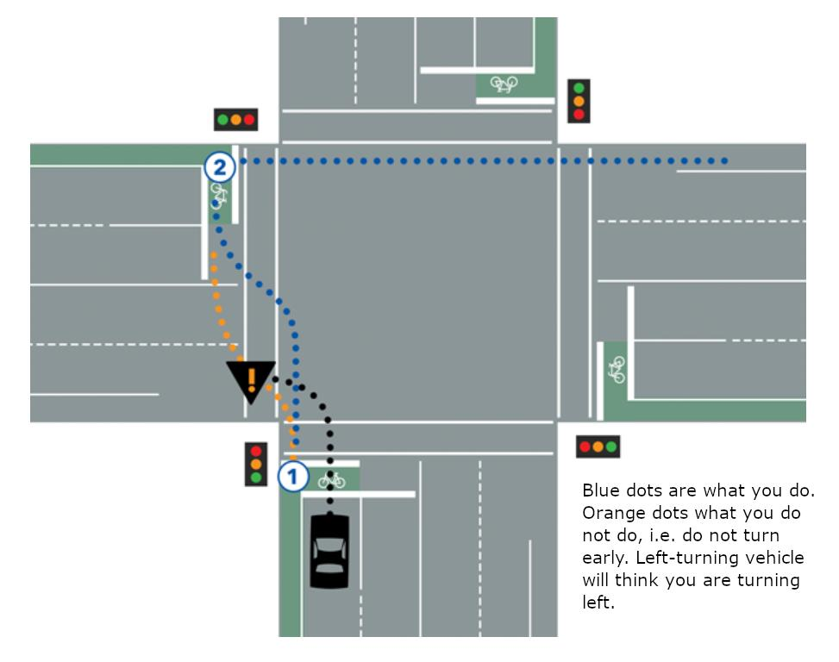 Some riders have been puzzled by this, and this is quite reasonable. They are not commonly taught in cycle training and are a bit counter-intuitive. In my view they are a useful option. But it is worth thinking about all the other options too.
The Highway Code sayeth (Rule 74, in the cycling section):
On the right. If you are turning right, check the traffic to ensure it is safe, then signal and move to the centre of the road. Wait until there is a safe gap in the oncoming traffic and give a final look before completing the turn. It may be safer to wait on the left until there is a safe gap or to dismount and push your cycle across the road.
That last sentence is important. In any turn situation, if things get hairy, head for the left side and have a think.
How you make a right turn depends on 2 things, the current traffic level and the junction type and design.
- Quiet traffic. Just have a good look, when clear move to the middle, watch the oncoming road, when clear make the turn.
- Busy traffic, unsignalized.
  - Do as in (1.) but be patient waiting for a gap.
  - If there is a pedestrian crossing near, stay on the left and use that.
  - If the road on the left has a give way line and there is room, make a 2-stage right.
- Signalised junction, lots of traffic.
  - Make a 2-stage right (make sure you can see the lights, if not possible, watch the traffic behind you).
  - Taking care, move across the traffic lane(s) as in (1.).
- Signalised junction with a signalled right turn lane.
  - If traffic is light, move across to the right turn lane and turn with any turning motor traffic.
  - On a big junction with a lot of traffic, use a 2-stage right.
- Junction with cycle crossing lights. There are some of these now in London. Follow the cycle lanes and the cyclist signals.
There is a good article with diagrams (this is where the one above was published) on the site of the Australian “rideOn” website, https://rideonmagazine.com.au/how-to-turn-right/. Note in Australia 2-stage rights are called “hook turns”.
Bruce Lynn. Southwark Cyclists Healthy Rides Co-odinator. 7 Feb 2020.
www.healthyrider.weebly.com
Link to view this document: http://bit.ly/39ssnPJ

